Business Problem:

Location is vital to the success of a business. An entrepreneurship’s popularity will vary greatly on basis of the location in which it establishes its operation. The objective of this project was to create a localized model that tries to predict what type of venue would be popular based on its geographical coordinates, information that could be useful for entrepreneurs or local governments.

Data:

For this project two sources of data were used: geographical coordinates for the different neighborhoods in the test city Toronto and the geographical coordinates of the currently most popular venues in the city’s boroughs.

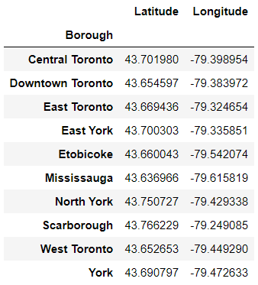 For the neighborhood data, an archived Wikipedia entry for Canada's postal codes (available in https://en.wikipedia.org/w/index.php?title=List_of_postal_codes_of_Canada:_M&oldid=945633050.) was used in conjunction with data from the Geocoder Python package(the data was available in its entirety at http://cocl.us/Geospatial_data, and this source was prefered in order to reduce the number of data fetching in the code)

For the venue data, Foursquared API was used to source 200 venues in each borough with data available in 24/03/2020

The neighborhood data was used to build a table containing a reference coordinate for each borough.

These locations were used to run queries in the Foursquared API to look for the most popular venues in the vicinity for each borough

The venue data was then processed and fed to a prediction model.